**Project Documentation**

**Insight Stream : Navigating the News landscape**

**1.Introduction**

* **Project Title: Insight Steam : Navigating the Newslandscape**
* **Team ID:NM2025TMID31582**
* **Team Leader:**
* NAME: SHARMILA B

MAIL ID: [selvamanisharmila8@gmail.com](mailto:selvamanisharmila8@gmail.com)

* **Team Members**
* NAME: ANITHA D

MAIL ID: [ad4656197@gmail.com](mailto:ad4656197@gmail.com)

* NAME: DEEPIKA R

MAIL ID: [deebika010@gmail.com](mailto:deebika010@gmail.com)

* NAME: YOGAPRIYA J

MAIL ID: [yogapriyaj8427@gmail.com](mailto:yogapriyaj8427@gmail.com)

**2. Project Overview**

* **Purpose:** Insight Stream empowers professionals and organisational to navigate emerging trends, share real time insights , and adapt to evolving business landscape through collaborative learning, analysis and communication
* **Features:**
* Live Insight Streams
* Secure chat system
* Feedback and review system
* Admin control panel

**3. Architecture**

* Frontend: React.js with Bootstrap and Material UI

**4. Setup Instructions**

* **Prerequisites:**
* Node.js
* Git
* React.js
* Express.js – Visual Studio Code
* **Installation Steps:**

# Clone the repository git clone

# Install client dependencies cd

client npm install

# Install server dependencies cd

../server npm install

**5. Folder Structure**

SB-Works/

|-- client/ # React frontend

|__components/

L__ pages/

|__ server/ # Node.js

**6. Running the Application**

* + **Frontend:**
* cd client
* npm start
  + **Access: Visit** [**http://localhost:3000**](http://localhost:3000)

**7. API Documentation**

* + **User:**
* /api/user/register
* /api/user/login
  + **Projects:**
* /api/projects/create
* /api/projects/:id • Applications: /api/apply
  + **Chats:**
* /api/chat/send
* /api/chat/:userId

**8. Authentication**

* **JWT-based authentication for secure login**
* **Middleware protects private routes**

**9. User Interface**

* + Landing Page
  + Freelancer Dashboard
  + Admin Panel
  + Project Details Page

**10. Testing**

* + Manual testing during milestones
  + Tools: Postman, Chrome Dev Tools

**11. Screenshots**

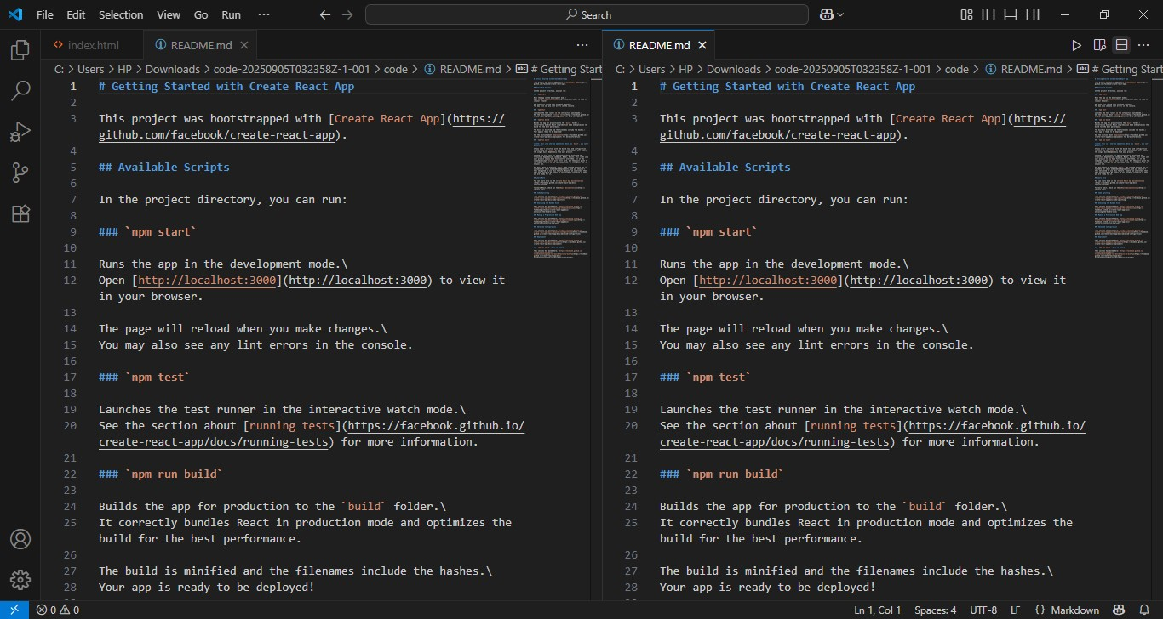

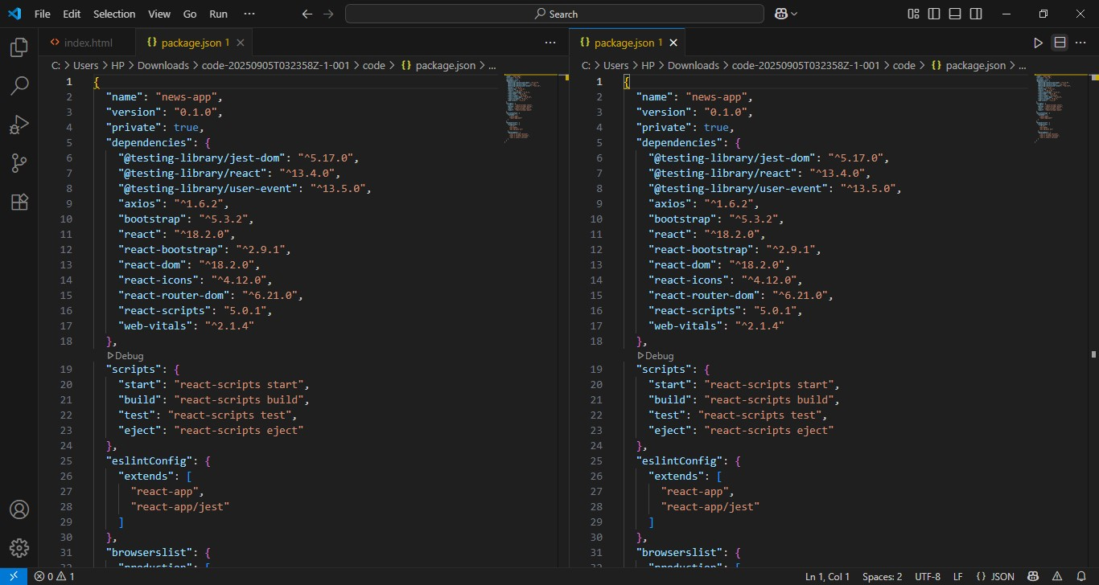

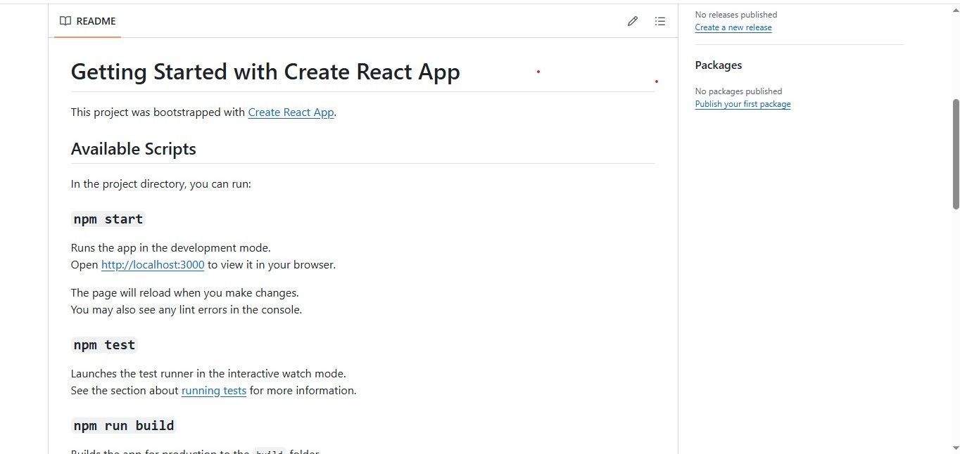

12. Known **Issues**

* API Rate Limits
* Server Problem
* Navigation Glitches

13. Future Enhancements

* Analytics Dashboard
* Search Functionality
* User Authentication